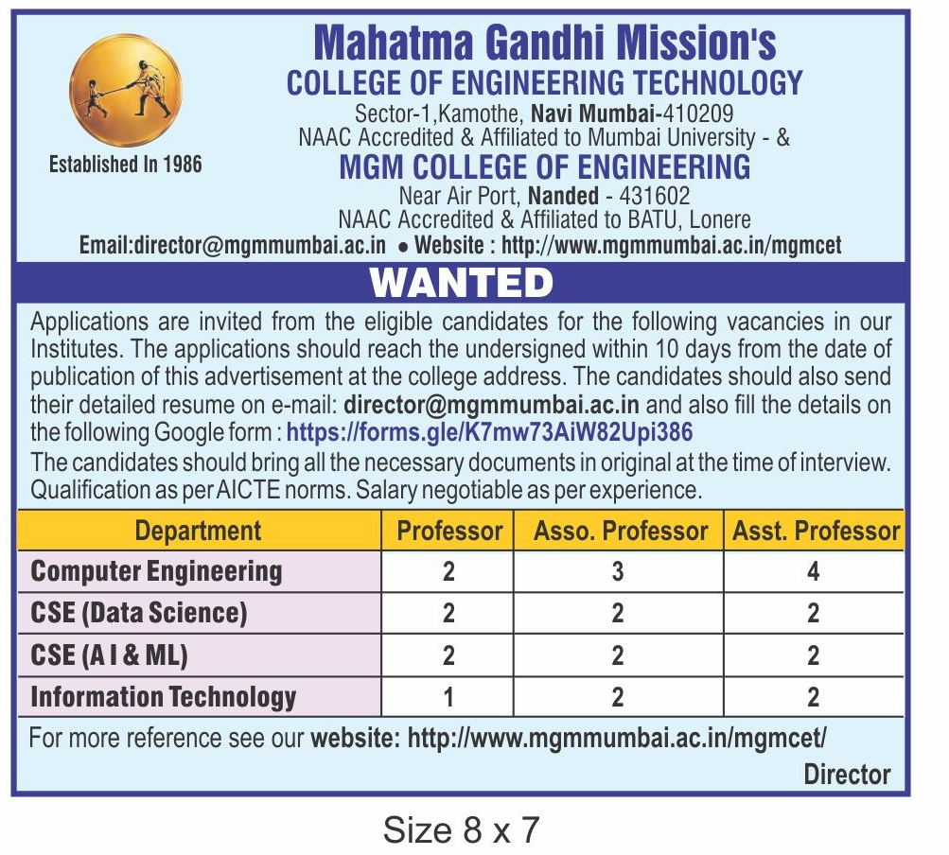

Please Click the following link to apply for applicable Post:

[**https://forms.gle/K7mw73AiW82Upi386**](https://forms.gle/K7mw73AiW82Upi386)